**A Draft Proposal on Making a Smart SRM Campus**

# ABSTRACT

Banking has evolved from a traditional branch banking setup to a computerized era. Banking moved from branches to electronic form via Internet Banking. After the usage of cards like ATM cards, Debit cards and Credit cards, the new type of card which is emerging right now is contactless card using the Near Field Communication or NFC technology. Such a card need to be tapped or waved at a close proximity of the merchant terminal to complete a transaction. This project intends to make use of the Institute issued ID cards as a means of ‘tap-and-pay’ payment mode within the campus.

# PROBLEM STATEMENT

Digitalization of money using Institute ID card to make a smart SRM Campus.

# PROBLEM DEFINITION

The current prevailing transaction process involves usage of cash (on all on-campus shops) and usage of online transactions such as UPI or wallet based transactions. Carrying of cash itself is a hassle on its own, let alone remembering the PIN of the online-payment methods. Apart from that shop owners face the difficulty of tracking who made the payment and who did not, at the time of peak hours.

# PROBLEM MITIGATION PLAN

The proposed method will help us to overcome the above-mentioned problems by having the SRM ID card do all the work so that it becomes easier for the students to make the transactions as well as helps the shop owners not suffer any losses.

The SRM ID card contains reasonable amount of storage/memory space, however, this project only requires the student’s Registration Number which will then fetch all the personal details and display in the web app of the project from servers (college administration can help with these). After connecting their online wallets to their respective accounts and an authenticity verification test, students can access the tap-and-pay method using their ID cards.

# PERKS

* Digitalization of Institute facilities.
* The staff, the students as well as the parents can track the spending of money (on-campus).
* Removes the need to carry physical cash money.
* The campus requirement to carry ID card becomes an important responsibility as well as an easy method for small transactions.

# CHALLENGES

* People may use other peoples’ ID cards for false transactions
* Server issues and technical glitches
* Requires a separate scanner machine for magnetic scanning of the ID card (for now, because **phones these days support NFC transactions** so the merchant can use their phone for the transaction)

# Technical Requirements

## For people with ID card

* Need to register the account for the ‘mini-bank.’
* Need to be a valid current user of the ID card (old ID cards from alumni and previous staff will be invalid).
* Connecting online wallets or UPIs to the respective accounts and ID cards.
* Every time a transaction is done the user will receive a mail or a message regarding the same (whichever service they opt for; default is messages on the attached phone number)

## For shop owners

* Need to register as a commercial shop for the ‘mini-bank.’
* Connecting the online wallets or UPIs to the respective accounts of the shops.
* Every time a transaction is done the shop owners will receive a mail or message (whichever service they opt for; default is messages on the attached phone number)

## For server-side and technical maintenance

* Maintenance of the web app.
* Need to setup transaction limit (Ex – ₹5,000)
* Breaking or damaging of ID card is already being maintained by the SRM administration.

# Step by step procedure for the transactions to work

## For people with ID card

1. Make an account on the web app entering Name, Registration Number, Phone Number (OTP verification), Username, Password, Retype Password, SRM email ID (OTP verification).
2. In the second page user needs to connect any wallet (Paytm, PhonePe, Amazon Pay wallet) to their account.
3. The user can later fill their profile after the required information is provided.
4. User verification will take place based on the information they have provided and after successfully verified they can start to use their ID card as a mode of payment.

## For shop owners

1. Make an account on the web app entering the Shop Name, Phone Number, Username, Password, Retype Password, Personal email ID.
2. Shop owners will make a request for the scanner tool from SRM administration.
3. Once they receive the tool and its unique Merchant ID (mID), they can activate their account for transactions by entering the mID.
4. Activation will only be done after verification and mID receival. After this, the tool will be connected to the account of the shop owner and they can start receiving money.

# NFC PAYMENT METHOD FLOWCHART

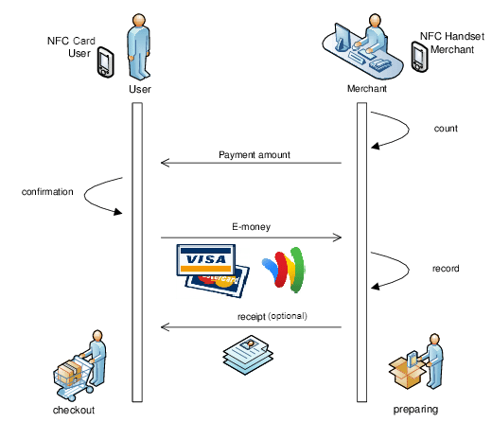

What is NFC?

The NFC payment works NFC (near field communication) is what enables two devices to communicate wirelessly when they are close together. NFC is a subset of something called RFID (radio-frequency identification), a technology that allows us to identify things through radio waves. RFID has been used for decades for things like scanning items in grocery stores and luggage on baggage claims, and tagging cattle. NFC, which was introduced in the early 2000s, uses a specific RFID frequency (13.56MHz, to be exact) for close-range communications.

|  |  |
| --- | --- |
| Name | Prerak Lodha |
| Reg. No. | RA2111026010394 |
| Branch | CSE (AIML) |
| Section | U2 |